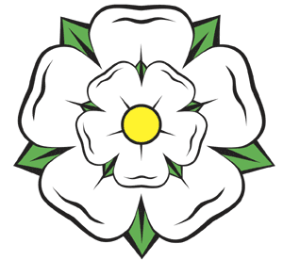

##### **YORKSHIRE FOLK DANCE WEEKEND**

### *10th Event*

**4th, 5th & 6th July 2025**

***Friday evening to Sunday mid-afternoon***

### Drax, Yorkshire

*between Selby (North Yorkshire) and Goole (East Yorkshire)*

*Our invited guests are:*

**Geoff Cubitt, Bernie Culkin,**

#### Fran Bulpit, Philip Rowe &

#### Dave Yeomans

#### Outline Programme:

Friday Evening – Welcome Dance to suit all tastes

Saturday – Two morning workshops, lunch break, two afternoon workshops,

Grand Evening Ball.

Sunday – Two morning workshops, lunch break / carvery, afternoon Wind Down Dance.

Website [http://yfdw.org.uk](http://yfdw.org.uk/)

Email [yfdw.drax@gmail.com](mailto:yfdw.drax@gmail.com)



##### **YORKSHIRE FOLK DANCE WEEKEND**

### *10th Event*

**4th, 5th & 6th July 2025**

***Friday evening to Sunday mid-afternoon***

### Drax, Yorkshire

*between Selby (North Yorkshire) and Goole (East Yorkshire)*

*Our invited guests are:*

**Geoff Cubitt, Bernie Culkin,**

#### Fran Bulpit, Philip Rowe &

#### Dave Yeomans

#### Outline Programme:

Friday Evening – Welcome Dance to suit all tastes

Saturday – Two morning workshops, lunch break, two afternoon workshops,

Grand Evening Ball.

Sunday – Two morning workshops, lunch break / carvery, afternoon Wind Down Dance.

Website [http://yfdw.org.uk](http://yfdw.org.uk/)

Email [yfdw.drax@gmail.com](mailto:yfdw.drax@gmail.com)